

**HARRISDALE SENIOR HIGH SCHOOL**

**YEAR 11 SEMESTER 1 2021**

**QUESTION / ANSWER BOOKLET**

CHEMISTRY

|  |  |  |  |  |  |  |
| --- | --- | --- | --- | --- | --- | --- |
|  |  |  |  |  |  |  |

**Student number: in figures**

**In Words _____________________________________**

Time allowed for this paper

Reading time before commencing work: ten minutes

Working time: 2 hours 30 minutes

Materials required/recommended for this paper

*To be provided by the supervisor*

This Question/Answer booklet

Multiple-choice answer sheet

Chemistry Data booklet

*To be provided by the candidate*

Standard items: pens (blue/black preferred), pencils (including coloured), sharpener, correction fluid/tape, eraser, ruler, highlighters

Special items: up to three calculators, which **do not** have the capacity to create or store programmes or text, are permitted in this ATAR course examination

Important note to candidates

No other items may be taken into the examination room. It is **your** responsibility to ensure that you do not have any unauthorised material. If you have any unauthorised material with you, hand it to the supervisor **before** reading any further.

Structure of this paper

|  |  |  |  |  |  |
| --- | --- | --- | --- | --- | --- |
| Section | Number of questions available | Number of questions to be answered | Suggested working time (minutes) | Marks available | Percentage of examination |
| Section One Multiple–choice | 20 | 20 | 35 | 40 | 25 |
| Section Two Short answer | 7 | 7 | 55 | 56 | 35 |
| Section Three Extended answer | 5 | 5 | 60 | 64 | 40 |
|  |  |  |  | **Total** | 100 |

Instructions to candidates

1. The rules for the conduct of the Western Australian external examinations are detailed in the *Year 12 Information Handbook 2020: Part II Examinations*. Sitting this examination implies that you agree to abide by these rules.

2. Write your answers in this Question/Answer booklet preferably using a blue/black pen. Do not use erasable or gel pens.

3. Answer the questions according to the following instructions.

Section One: Answer all questions on the separate Multiple–choice answer sheet provided. For each question, shade the box to indicate your answer. Use only a blue or black pen to shade the boxes. Do not use erasable or gel pens. If you make a mistake, place a cross through that square, then shade your new answer. Do not erase or use correction fluid/tape. Marks will not be deducted for incorrect answers. No marks will be given if more than one answer is completed for any question.

Section Two and Three: Write your answers in this Question/Answer booklet.

4. When calculating numerical answers, show your working or reasoning clearly. Your working should be in sufficient detail to allow your answers to be checked readily and for marks to be awarded for reasoning. Express numerical answers to the appropriate number of significant figures and include appropriate units where applicable.

5. You must be careful to confine your answers to the specific questions asked and to follow any instructions that are specific to a particular question.

6. Supplementary pages for the use of planning/continuing your answer to a question have been provided at the end of this Question/Answer booklet. If you use these pages to continue an answer, indicate at the original answer where the answer is continued, i.e. give the page number.

7. The Chemistry Data booklet is to be handed in with your Question/Answer booklet.

**Section One: Multiple–choice 25% (40 Marks)**

This section has **20** questions. Answer **all** questions on the separate Multiple–choice answer sheet provided. For each question shade the box to indicate your answer. Use only a blue or black pen to shade the boxes. Do not use erasable or gel pens. If you make a mistake, place a cross through that square, then shade your new answer. Do not erase or use correction fluid/tape. Marks will not be deducted for incorrect answers. No marks will be given if more than one answer is completed for any question.

Suggested working time: 35 minutes.

1. In which one of the following compounds do the two ions have the same electron configuration?

(a) Na2O

(b) LiF

(c) KBr

(d) MgCℓ­2

2. Which one of the following, concerning the structure of atoms, was concluded by English physicist Joseph John (JJ) Thomson?

(a) Electrons could only be found in specific energy levels (quantized).

(b) Atoms are small, hard spheres that are indivisible.

(c) Atoms were divisible, they had smaller constituent parts.

(d) An atom’s positive charge was concentrated in a small, dense centre.

3. Which one of the following **incorrectly** describes the observed changes with increasing atomic number in group 17 (the halogens)?

(a) electronegativity decreases

(b) mass increases

(c) reactivity increases

(d) atomic radius increases

4. The correct IUPAC name for CH3CH2CCH3CHCH3 is

(a) 3–methylpentane.

(b) 2–methylpentane.

(c) 3–methylpent–2–ene.

(d) 2–methylpent–3–ene.

5. Substance “X” is a green, brittle solid that produces toxic gases upon heating. Substance X is soluble in water and conducts electricity when in solution. It cannot conduct electricity when in solid form. Substance X could be

(a) copper carbonate.

(b) nickel chloride.

(c) hydrogen chloride.

(d) iron(III) nitrate.

6. Which diagram correctly represents the bonding in the molecule, methanol, CH3OH?

|  |  |
| --- | --- |
| (a) | (b) |
| (c) | (d) |

7.. Select the structure that correctly represents the cyclic compound with the IUPAC name ‘2,3-dichlorocyclopentene.’

|  |  |
| --- | --- |
| (a) | (b) |
| (c) | (d) |

8. Consider the phase changes shown below.

I – melting wax

II – H2O(g) ⇌ H2O(ℓ)

III – freezing water

IV – CO2(s) ⇌ CO2(g)

How many of these phase changes are exothermic?

(a) 1

(b) 2

(c) 3

(d) 4

9. For the energy profile diagram below, select the row which correctly classifies the reaction as exothermic or endothermic and provides the correct heat of reaction.

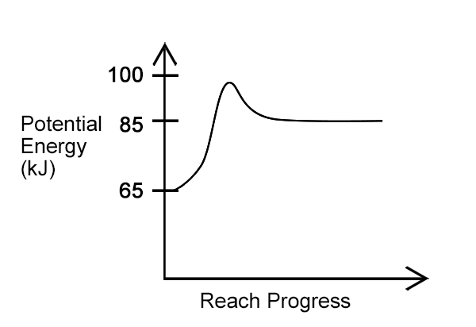

|  |  |  |
| --- | --- | --- |
|  | **Exothermic or Endothermic** | **Heat of reaction** |
| (a) | Exothermic | –85kJ |
| (b) | Endothermic | +85kJ |
| (c) | Exothermic | –20kJ |
| (d) | Endothermic | +20kJ |

10. Which one of the following substances could not be formed when excess iodine reacts with butane in the presence of UV light?

(a) 1–iodobutane

(b) 2–iodobutane

(c) 3–iodobutane

(d) 1, 2–diiodobutane

11. Below is the thermochemical equation for the combustion of butane.

2 C4H10(g) + 13 O2(g) → 8 CO2(g) + 10 H2O(g)     ΔH = –2877 kJ mol L–1

Which one of the following represents the amount of energy released by burning 5.00 mol of butane?

(a) 1159.8 kJ

(b) 7192 kJ

(c) 14 385 kJ

(d) 28 770 kJ

Questions 12 –16 refer to the experiment below ***investigating the energy output of various alcohols***

**The Method**

|  |  |
| --- | --- |
| 1. Measure 100 mL of cold tap water into a conical flask. 2. Clamp the flask at a suitable height so that an alcohol burner can easily be placed below. 3. Weigh the alcohol burner (and cap) containing the alcohol and record this mass and the name of the alcohol. 4. Record the initial temperature of the water in the flask. 5. Place the alcohol burner under the flask and light the wick. 6. Allow the alcohol to heat the water so the temperature rises by 40 °C. |  |
| 1. Replace the cap to extinguish the flame. 2. Reweigh the alcohol burner and cap and record the mass. 3. Calculate 4. Using a fresh 100 mL of cold tap water, repeat the experiment with other alcohols. | |

12. Which one of the following is the dependent variable for this experiment?

(a) the change in temperature of the water

(b) the mass of alcohol used to heat the water

(c) the type of alcohol placed in the burner

(d) the time taken to heat up the water by 40oC

13. Which one of the following is the most important variable that must be controlled to ensure this experiment is valid?

(a) distance between burner and conical flask

(b) initial temperature of the water

(c) initial mass of the alcohol used

(d) same thermometer and conical flask used each time

14. Below is an image of the thermometer with the initial temperature reading. Which of the following is the correct reading?

PPLATO | FLAP | PHYS 7.2: Temperature, pressure and the ideal gas laws

(a) 18 ± 1 oC

(b) 19 ± 1 oC

(c) 18.0 ± 0.5 oC

(d) 19 ± 0.5 oC

15. If the experiment were carried out using a digital thermometer instead of standard thermometer. Which of the following would be true?

I improve accuracy

II improve precision

III reduce random error

IV reduce need for repeat trials

(a) I and II only

(b) I, II and III only

(c) I and IV only

(d) I, II, III and IV

16. The data collected during this experiment is

(a) primary data and it is quantitative.

(b) primary data and it is qualitative.

(c) secondary data and it is quantitative.

(d) secondary data and it is qualitative.

17. Consider the two samples described below.

|  |  |
| --- | --- |
| Sample 1 | 70.0 g of pure copper |
| Sample 2 | 50.0 g of pure potassium |

The number of copper atoms in sample 1

(a) is equal to the number of potassium atoms in sample 2.

(b) is less than the number of potassium atoms in sample 2.

(c) is greater than the number of potassium atoms in sample 2.

(d) is less than 6.022 x 1023.

18. For an endothermic reaction

(a) the enthalpy of the reactants increases.

(b) chemical energy is transformed to heat energy.

(c) the heat of reaction is negative.

(d) there is no overall change in the amount of energy during the reaction.

19. Which one of the following is the **best** description of a sustainable fuel?

(a) a fuel with lower carbon emission than fossil fuels such as coal and natural gas

(b) a fuel produced from organic matter

(c) a fuel produced from renewable resources that can provide energy with causing damage to environment

(d) a fuel that can be mixed with fossil fuels to increase the energy output of a fossil fuel

20. Bioethanol is a biofuel which is produced by the fermentation of corn, potatoes or grain. It is among the best–established biofuels. Which of the following is the correct chemical formula for bioethanol?

(a) CH3COOH

(b) CH3OH

(c) CH3CH2OH

(d) C2H4

**End of Section One**

|  |  |
| --- | --- |
| **Section Two: Short answer** | **35% (56 Marks)** |

This section has **seven** questions. Answer **all** questions. Write your answers in the spaces provided.

Supplementary pages for the use of planning/continuing your answer to a question have been provided at the end of this Question/Answer booklet. If you use these pages to continue an answer, indicate at the original answer where the answer is continued, i.e. give the page number.

Suggested working time: 55 minutes.

|  |  |
| --- | --- |
| **Question 21** | **(9 marks)** |

Below is a table containing the names of common materials used in a range of industries including building, cooking, medicine and cleaning.

|  |  |  |  |
| --- | --- | --- | --- |
| steel | aluminium | brine | sodium chloride |
| potassium permanganate | natural gas | carbon tetrachloride | iodine |

(a) Write the names of the five pure substances in the table below. Write the chemical formula for each substance. (6 marks)

|  |  |
| --- | --- |
| **Name of pure substance** | **Chemical formula** |
|  |  |
|  |  |
|  |  |
|  |  |
|  |  |

(b) State **three** differences between ‘pure’ and ‘impure’ substances. Using examples from above might assist your answer. (3 marks)

One:

Two:

Three:

**Question 22 (10 marks)**

Below is a list of common cations and anions.

|  |  |  |  |
| --- | --- | --- | --- |
| **Name of substance** | **Cation** | **Anion** | **Chemical formula** |
| Potassium sulfide | K+ | S2– |  |
| Iron(III) dichromate | Fe3+ | Cr2O72– |  |
| Calcium ethanoate | Ca2+ | CH3COO– |  |
| Lead(IV) hydroxide | Pb4+ | OH– |  |

(a) Complete the table above by combining these ions to write an ionic formula for each of the four substances. (4 marks)

(b) Describe the nature of, and key parts that make up an ‘ionic bond’ .

(2 marks)

(c) Using potassium sulfide as the example, explain how an ionic bond forms between potassium and sulfur atoms. (4 marks)

**Question 23 (5 marks)**

A beaker has the following three substances mixed together.

• water – H2O(s)

• potassium nitrate – KNO3(s)

• barium sulfate – BaSO4(s)

Write a clear step–by–step method that could be used to successfully separate this mixture into its three individual components.

|  |
| --- |
| Diagram |

Method

|  |  |
| --- | --- |
| **Question 24** | **(10 marks)** |

Below is an incomplete graph showing the 1st ionisation energies of the first 19 elements of the Periodic Table. Hydrogen and helium have been shown on the graph.

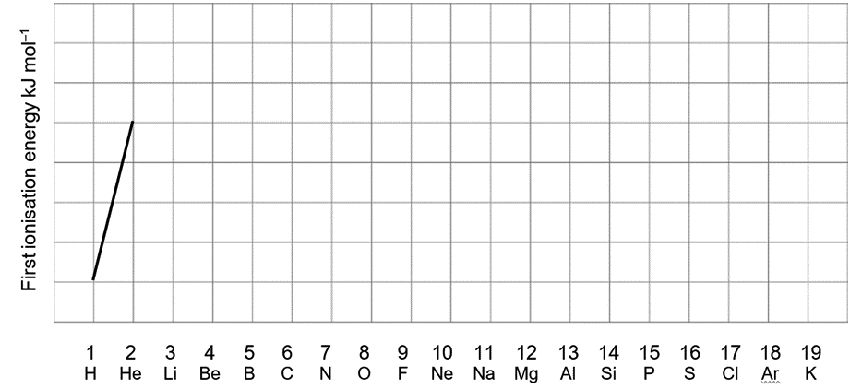

(a) Complete the graph above to show the trends in 1st ionisation energy across the first 19 elements. (4 marks)

(b) Another property that sees a trend across the periodic table is ‘electronegativity.’ Describe this property. (2 marks)

(c) State the trend in electronegativity across a period of the periodic table. Use your understanding of atomic structure to explain why this trend occurs. (3 marks)

(d) Complete the sentence by circling the correct word. (1 mark)

‘As the first ionisation energy of an atom increases; the electronegatively of the atom. Increases / decreases.

**Question 25 (6 marks)**

The mass spectrum for an element is shown below

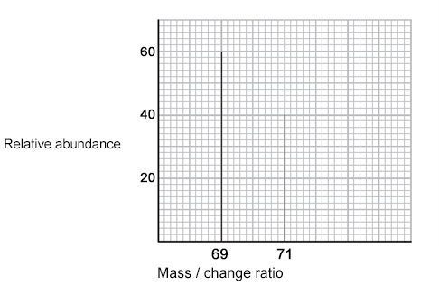

**Mass / Change Ratio**

**Relative Abundance**

(a) State **two** differences and **one** similarity between the isotopes represented above. (3 marks)

Difference

Difference

Similarity

(b) Calculate the relative atomic mass of the element using the data in the mass spectrum. (3 marks)

**Question 26 (7 marks)**

Use IUPAC nomenclature to name the alkanes and alkenes below.

|  |  |
| --- | --- |
| **Structural formula** | **IUPAC name** |
|  |  |
|  |  |
|  |  |
|  |  |
|  |  |
| CH3CH2CH2CHCH2 |  |
| CH3CH2CHCH3CH2CH2CHBrCH3 |  |

**Question 27 (9 marks)**

Chlorine can be produced by various processes. One method is by the [electrolysis](https://en.wikipedia.org/wiki/Electrolysis) of a [sodium chloride](https://en.wikipedia.org/wiki/Sodium_chloride) solution ([brine](https://en.wikipedia.org/wiki/Brine)). Another method is by the direct oxidation of hydrogen chloride with oxygen.

(a) Below are two equations that represent two different methods. Write coefficients to balance each of these equations. (2 marks)

**Electrolysis:**

___ NaCℓ (aq) + ____ H2O(ℓ) → ____ Cℓ2(g) + ____ H2(g) + ___NaOH(aq)

**Direct oxidation:**

___ HCℓ (aq) + ___ O2(g) → ___ Cℓ2(g) + ___ H2O(ℓ)

Chlorine can be prepared in the laboratory by the reaction of manganese dioxide with hydrochloric acid, HCℓ(aq), as described by the balanced chemical equation below.

MnO2(s) + 4 HCℓ (aq) ⟶ MnCℓ2(aq) + 2 H2O(ℓ) + Cℓ2(g)

(b) Calculate the minimum mass of hydrogen chloride required to produce chlorine gas when 2.50 kg of manganese dioxide is used in this process.

(4 marks)

(c) Calculate the mass of chlorine that would be required to produce 100 g of Aluminium Chloride (AℓCℓ3) (3 marks)

**End of Section Two**

|  |  |
| --- | --- |
| **Section Three: Extended answer** | **40% (64 Marks)** |

This section contains **five** questions. You must answer **all** questions. Write your answers in the spaces provided.

Where questions require an explanation and/or description, marks are awarded for the relevant chemical content and also for coherence and clarity of expression. Lists or dot points are unlikely to gain full marks.

Final answers to calculations should be expressed to the appropriate number of significant figures and include appropriate units where applicable.

Supplementary pages for the use of planning/continuing your answer to a question have been provided at the end of this Question/Answer booklet. If you use these pages to continue an answer, indicate at the original answer where the answer is continued, i.e. give the page number.

Suggested working time: 60 minutes.

_____________________________________________________________

**Question 28 (15 marks)**

Below is a list of solid substances with some of their physical properties

|  |  |  |  |
| --- | --- | --- | --- |
| **Name of substance** | **Melting point** | **Conductivity in solid form** | **Conductivity when mixed with water** |
| **Copper** | 1085 oC | High | Not tested |
| **Copper(II) sulfate** | 110 oC | Nil | Medium |
| **Chromium(III) sulfate** | 90 oC | Nil | Medium |
| **Sulfur** | 115 oC | Nil | Nil |

(a) Of the **four** substances copper is the substance with the highest melting point and highest conductivity. Use your understanding of the structure of copper to explain these observations. (4 marks)

(b) Explain why copper(II) sulfate and chromium(III) sulfate can conduct electricity when in aqueous solution but not when solid. (4 marks)

(c) It was observed that despite equal moles of copper(II) sulfate and chromium(III) sulfate being added to water the chromium(III) sulfate solution showed evidence of a slightly higher ability to conduct electricity. Explain this observation (3 marks)

(d) Sulfur is classified as a covalent molecular substance; its molecular structure is represented below. Name the bond present within this structure, describe the nature of the bond and classify the bond as either a strong or weak bond. (4 marks)

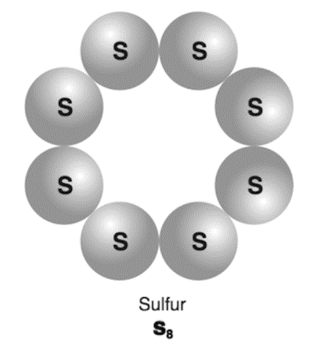

**Question 29 (13 marks)**

A copper ore mining operation began in the 1970’s in Recsk, Northern Hungary. Unfortunately, as soon as the roadways were finished the activities were suspended because of the decreasing price of copper in the international market. The mine was abandoned, and the roadways and shafts became flooded by ground water.

(a) Rock samples from the site were tested using a flame test and the colour of the flame produced gave a strong indication of high levels of copper. Circle the colour. (1 mark)

|  |  |  |  |
| --- | --- | --- | --- |
| Red | Blue | Green | Orange |

(b) Using the diagram of Bohr’s model of an atom below to **assist** in explaining, how heating an atom like copper in a flame will produce a coloured flame. (4 marks)

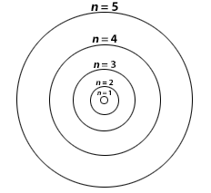

Copper has leached into the mine water. Concerned that some people had been drinking this water, a scientist decided to use atomic absorption spectroscopy to determine the concentration of copper in the water.

Firstly, he measured the absorbance levels of various solutions with known concentration of copper. The following results were obtained.

|  |  |
| --- | --- |
| **Copper concentration (mgL–1)** | **Absorbance levels (AU)** |
| 1.00 | 0.052 |
| 2.00 | 0.103 |
| 2.50 | 0.128 |
| 4.00 | 0.207 |

(c) Plot these results to produce a calibration curve below. (5 marks)



A spare grid is provided at the end of this Question/Answer booklet. If you need to use it, cross out this attempt and indicate clearly that you have redrawn it on the spare page.

**Question 29** (continued)

Water supplies are continually monitored by the Department of Health to ensure copper levels do not exceed Drinking Water Guidelines. These guidelines set two levels for copper:

• 1 mg L–1 for aesthetics to prevent taste and staining problems

• 2 mg L–1 to prevent any health–related problems

(d) The absorbance measured for the samples from the mine water are shown below. Use these data to describe any appearance or health issue that might be of concern. (2 marks)

|  |  |
| --- | --- |
| Sample 1 | 0.075 AU |
| Sample 2 | 0.078 AU |
| Sample 3 | 0.077 AU |

(e) State why the scientists analysed three samples rather than only one sample from the mine water. (1 mark)

**Question 30 (14 marks)**

Consider the combustion of propane (a fuel derived from fossil fuels) in excess oxygen gas. This reaction is said to have a change in enthalpy (∆H) of –2000 kJ mol–1. The reaction also has an activation energy of approximately 200 kJ.

(a) Write a balanced thermochemical equation for the combustion of propane. (3 marks)

|  |
| --- |
|  |

(b) In the space below sketch an energy profile diagram being sure to label the reactants, products, change in enthalpy (∆H) and activation energy (Ea). (5 marks)

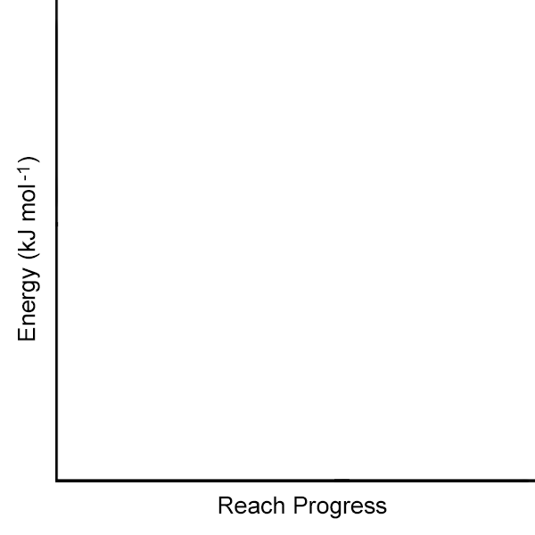

(c) Explain in terms of bond breaking and bond formation why this reaction is an exothermic reaction. (3 marks)

(d) A gas cylinder was known to contain 5.00 kg of propane. Calculate the number of carbon atoms in the cylinder. (3 marks)

**Question 31 (13 marks)**

Calcium carbonate is used in some toothpastes. To determine the mass of calcium carbonate in one gram of toothpaste, a 10.40 g sample of the toothpaste was reacted with excess hydrochloric acid solution.

When calcium carbonate reacts with hydrochloric acid solution the products are calcium chloride solution, water and carbon dioxide.

1. If the molecular equation describing this reaction is

CaCO3 + 2HCℓ → CaCℓ2 + CO2 + H2O

Write a balanced ionic equation for the reaction taking place, include state symbols. (2 marks)

|  |
| --- |
|  |

(b) If 3.570 g of carbon dioxide is produced, calculate the mass of calcium carbonate present in the 10.40 g sample. (4 marks)

1. Calculate the mass of calcium carbonate in one gram the toothpaste.

(1 mark)

1. By referring to the given equation in part (a) state what assumption has been made about the reaction of the acid with the toothpaste.

(1 mark)

1. Three students, Ryan, Rhea and Ella conducted an experiment using different quantities of the reactants. The following amounts of each reagent were combined in several trials of the experiment. What mass of the excess reagent is left over if they used 6.67g of CaCO3 and 5.86g of HCℓ in their trials. (5 marks)

**Question 32 (9 marks)**

Silicon dioxide (SiO2), also known as “silica”, is a natural compound made of two of the earth's most abundant materials: silicon (Si) and oxygen (O2).

Carbon dioxide is a chemical compound composed of one carbon and two oxygen atoms. It is often referred to by its formula CO2. It is present in the Earth's atmosphere at a low concentration and acts as a greenhouse gas. In its solid state, it is called “dry ice”.

(a) Calculate the percentage by mass of oxygen in each of these two substances. Showing your working in the table below. (3 marks)

|  |  |
| --- | --- |
| **% by mass of oxygen in silicon dioxide** | **% by mass of oxygen in carbon dioxide** |
|  |  |

(b) Silica is a very hard solid that can only be melted by heating to temperatures above 1,710 °C. Dry ice is a soft and crumbly solid that is converted to gaseous form with little heating. Use your understanding of the structure and bonding of these substances to explain these differences their properties. (6 marks)

**End of questions**

|  |  |  |
| --- | --- | --- |
| Section | Your mark | Marks available |
| Section One Multiple–choice |  | 40 |
| Section Two Short answer |  | 56 |
| Section Three Extended answer |  | 64 |
| TOTAL |  | **160** |

**%**

Supplementary page

Question number: _________________

Supplementary page

Question number: _________________

Spare grid

